1. There is problem with multi-threading as far as memory management is concern.
2. 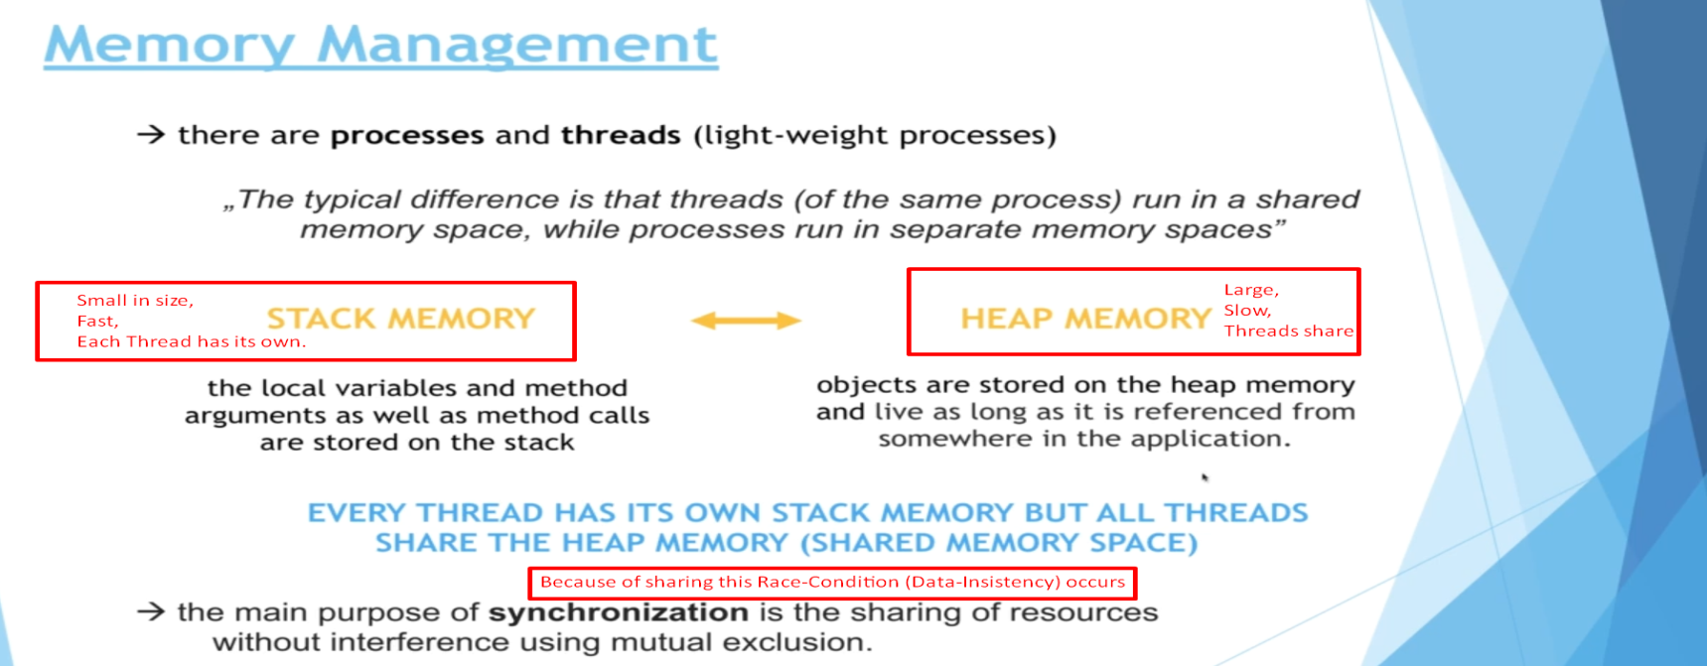
3. 